**CYCLE 2**

1. **Create an html page to display the following nested list**  
   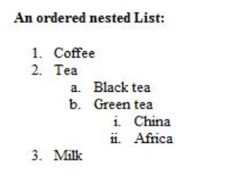

<html>

<head>

</head>

<body>

<b>An ordered nested List :</b>

<ol>

<li>Coffee</li>

<li>Tea</li>

<ol TYPE="a">

<li>Black tea</li>

<li>Green tea</li>

<ol TYPE="i">

<li>China</li>

<li>Africa</li>

</ol>

</ol>

<li>Milk</li>

</body>

</html>

**OUTPUT**

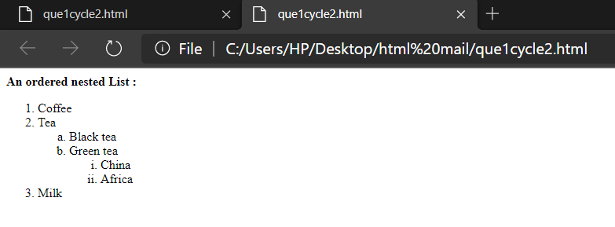

1. **Create links to three different pages on three different websites that should all open in a new window.**

<html>

<head>

</head>

<body>

<br><br>

<a href="https://www.facebook.com/" target="_blank">

<button>FACEBOOK</button></a>

<br><br>

<a href="https://www.youtube.com/" target="_blank">

<button>YOUTUBE</button></a>

<br><br>

<a href="https://www.google.com/" target="_blank">

<button>GOOGLE</button></a>

</body>

</html>

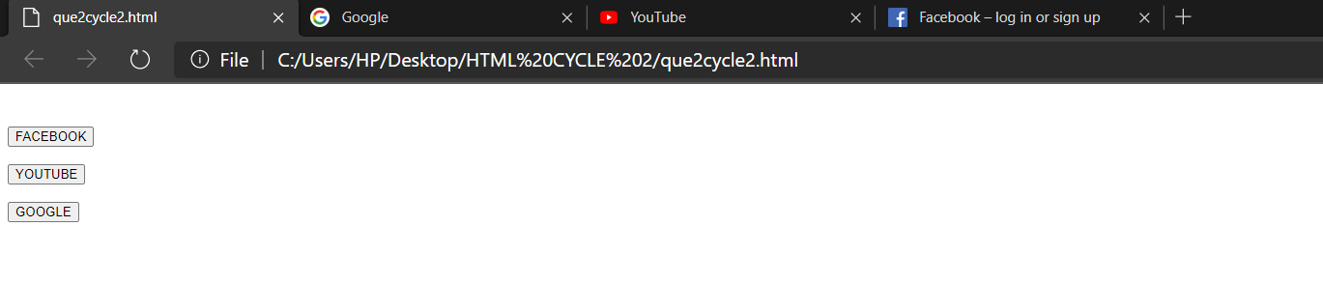

1. **Create a page with a link at the top of it that when clicked will jump all the way to the bottom of the page.**

<html>

<head>

</head>

<body>

<a href="#bottom">Click here to jump to the bottom of the page.</a>

<br>

a<br>

b<br>

c<br>

d<br>

e<br>

f<br>

1<br>

g<br>

h<br>

i<br>

j<br>

k<br>

l<br>

m<br>

n<br>

o<br>

p<br>

q<br>

r<br>

s<br>

t<br>

u<br>

v<br>

w<br>

x<br>

y<br>

z<br>

Monday<br>

Tuesday<br>

Wednesday<br>

Thursday<br>

Friday<br>

Saturday<br>

Sunday<br>

<a name="bottom">The bottom of the page.</a>

</body>

</html>

**OUTPUT**

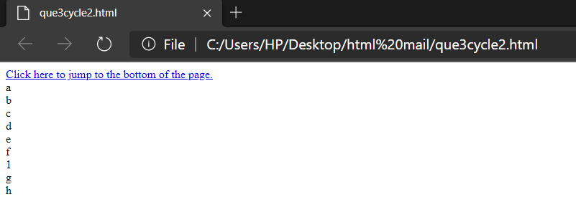

1. **Display three different images. Skip two lines between each image. Each image should have a heading.**

<html>

<head>

<body>

<br><br>

<h1>image 1</h1>

<img src="free.jpg" alt="Kitten" title="Kitten"/>

<br><br>

<h1>image 2</h1>

<img src="eli.png" alt="Puppy" title="Puppy"/>

<br><br>

<h1>image 3</h1>

<img src="wha.png" alt="Baby Panda" title="Baby Panda"/>

</body>

</html>

**OUTPUT**

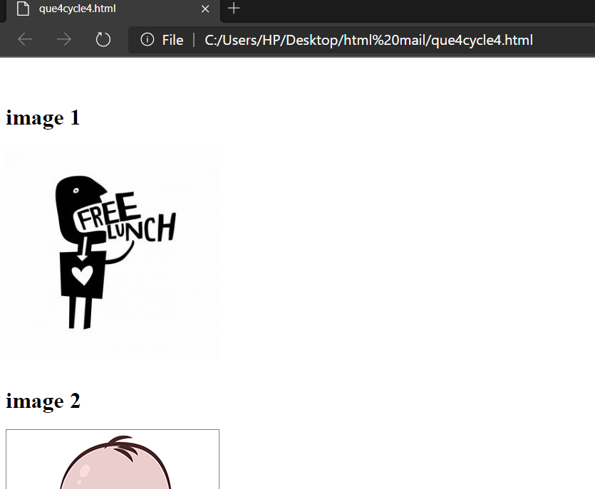

1. **Display an image that when clicked will link to a search engine of your choice in a different window**

<html>

<head>

</head>

<body>

<br><br>

<center>

<a href="https://www.facebook.com/" target="_blank">

<img src="facebook.png" alt="GOOGLE"/>

</a>

<p>redirect to FACEBOOK LOGIN PAGE.</p>

</center>

</body>

</html>

**OUTPUT**

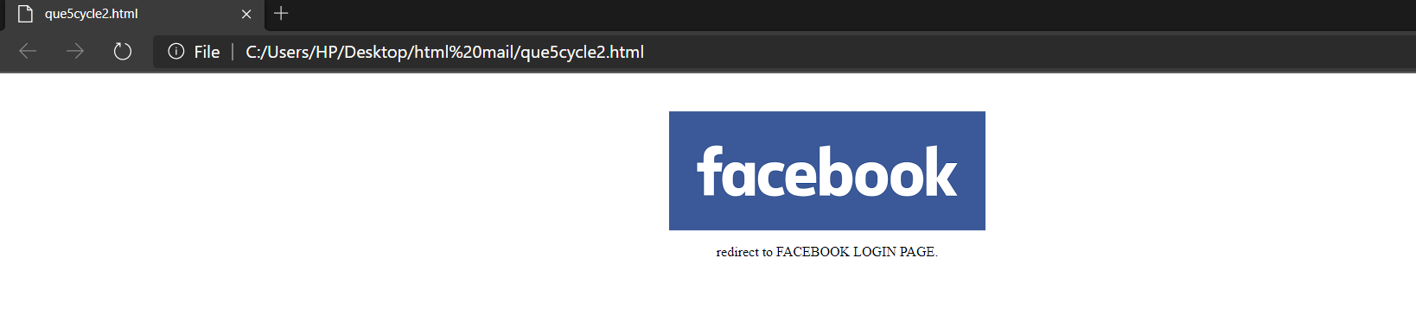

1. **Create the following Html Page using appropriate form controls**

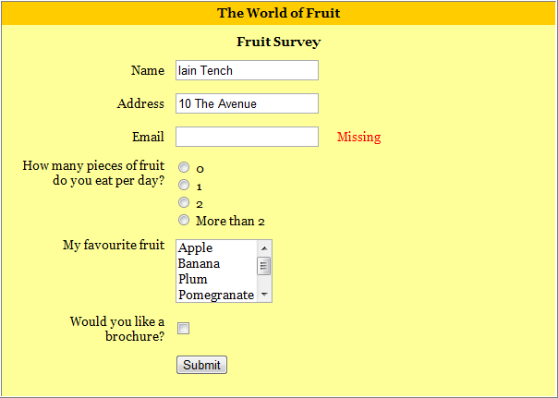

html>

<head>

<style>

.div_1{ background-color:orange; margin:10px; }

.div_2{ background-color:yellow; margin:10px; }

</style>

</head>

<body>

<center>

<div class="div_2">

<div class="div_1"><font size="4" face="Cooper"><h1>The World of Fruit</h1></font></div>

<form method="post">

<font size="4" face="Cooper"><h1 align="center" >Fruit Survey</h1></font>

<table align="center" cellpadding ="20" >

<tr>

<th>Name</th>

<td><input type="text" name="name" style="width:400px;" class="form-control" required=""></td>

</tr>

<tr>

<th>Address</th>

<td><input type="text" name="address" style="width:400px;" class="form-control" required=""></td>

</tr>

<tr>

<th>Email</th>

<td><input type="text" name="address" style="width:400px;" class="form-control" required=""></td>

<td><label style="color:red;"><b>Missing</b></label></td>

</tr>

<tr>

<th>How many pieces of fruit<br>do you eat per day?</th>

<td><input type="radio" name="0" value="0" >0<br><input type="radio" name="1" value="1">1<br><input type="radio" name="2" value="2" >2<br><input type="radio" name="More than 2" value="More than 2">More than 2</td>

</tr>

<tr>

<th>My favorite fruit</th>

<td><textarea rows="4" cols="12" name="favorite fruit">Apple Banana Plum Pomegranate Orange </textarea>

</td>

</tr>

<tr>

<th>Would you like a<br>brochure?</th>

<td><input type="checkbox" name="yes" value="on"></td>

</tr>

<tr>

<td align="center" colspan="2"><input type="submit" name="submit" value="submit"></td>

</tr>

</table>

</form>

</div>

</center>

</body>

</html>

**OUTPUT**

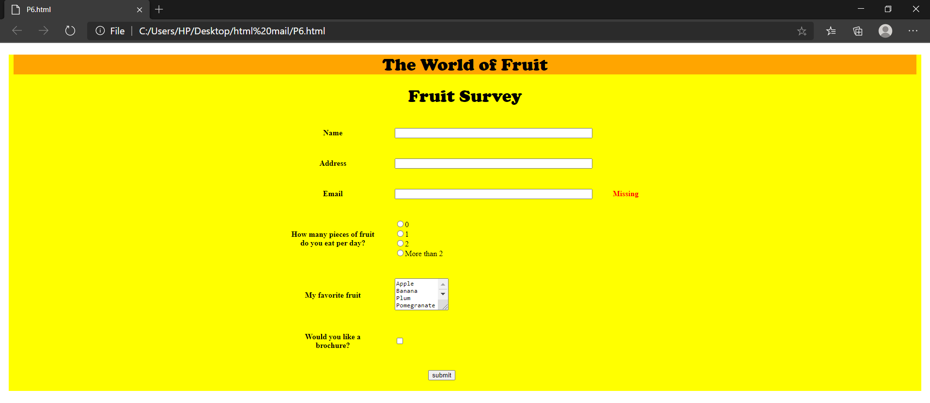

1. **Create an image map for ‘Kerala Map’. Map at least 3 districts so that when you click on that particular district the details regarding that district (eg: population, Area, Tourist Spots (with images), Monuments, Interesting Facts) should be displayed on a new page.**

<html>

<head>

</head>

<body>

<center>

<h1><u><font color="grey" face="Cooper">KERALA MAP</font></u></h1>

<map name="kerala">

<area shape="circle" coords="353,456,50" href="kottayam.html"/>

<area shape="circle" coords="270,159,50" href="wayanad.html"/>

<area shape="circle" coords="411,407,50" href="iduki.html"/>

</map>

<img src="kerala.jpeg" alt="kerala" usemap="#kerala"/>

</center>

</body>

</html>

**OUTPUT**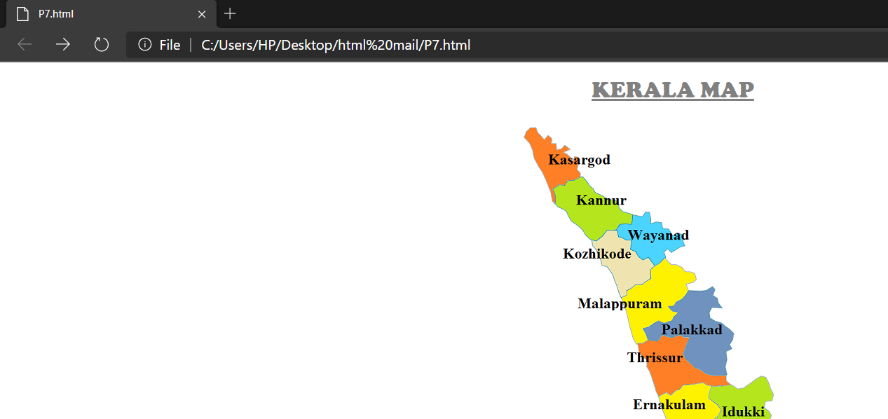

1. **Construct this puzzle looking thing**

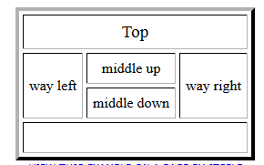

<html>

<head>

</head>

<body>

<br><br>

<table align="center" border="2" cellpadding="15" cellspacing="4">

<tr>

<th colspan="6"> Top </th>

</tr>

<tr>

<th rowspan="2"> way left </th>

<th colspan="2"> middle up </th>

<th rowspan="2"> way right </th>

</tr>

<tr>

<th colspan="2"> middle down </th>

</tr>

<tr>

<th colspan="6"> &nbsp; </th>

</tr>

</table>

</body>

</html>

**OUTPUT**

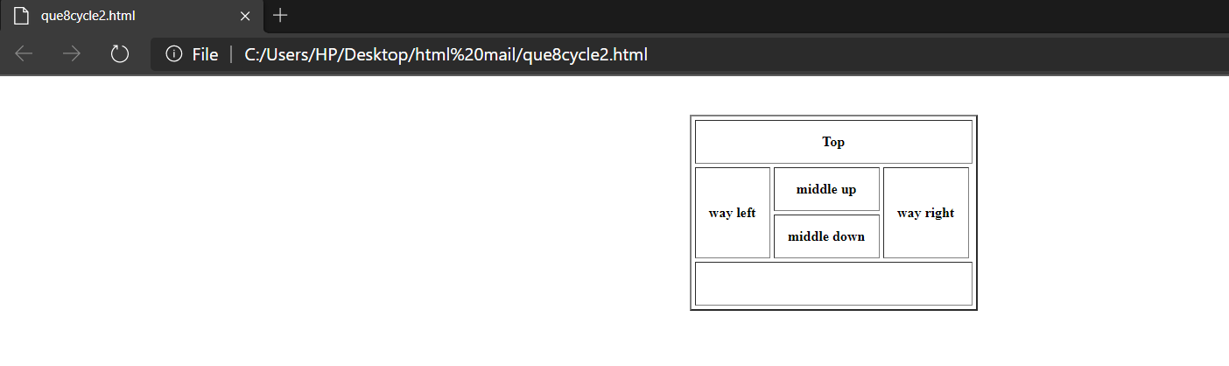

1. **Make up three image links for 3 web browsers and put them in a borderless table. Construct the table so that there is just a little space between the images.**

<html>

<head>

</head>

<body>

<br><br>

<table align="center" style= "border-collapse : collapse;">

<tr>

<td><a href="https://www.firefox.com/" target="_blank">

<img src="firefox.jpeg" alt="firefox" height="220" width="220"/>

</td>

</tr>

<tr>

<td><a href="https://www.google.com/chrome/" target="_blank">

<img src="chrome.jpeg" alt="chrome" height="220" width="220"/>

</td>

</tr>

<tr>

<td><a href="https://www.apple.com/in/safari/" target="_blank">

<img src="safari.png" alt="safari" height="220" width="220"/>

</td>

</tr>

</table>

</body>

</html>

**OUTPUT**

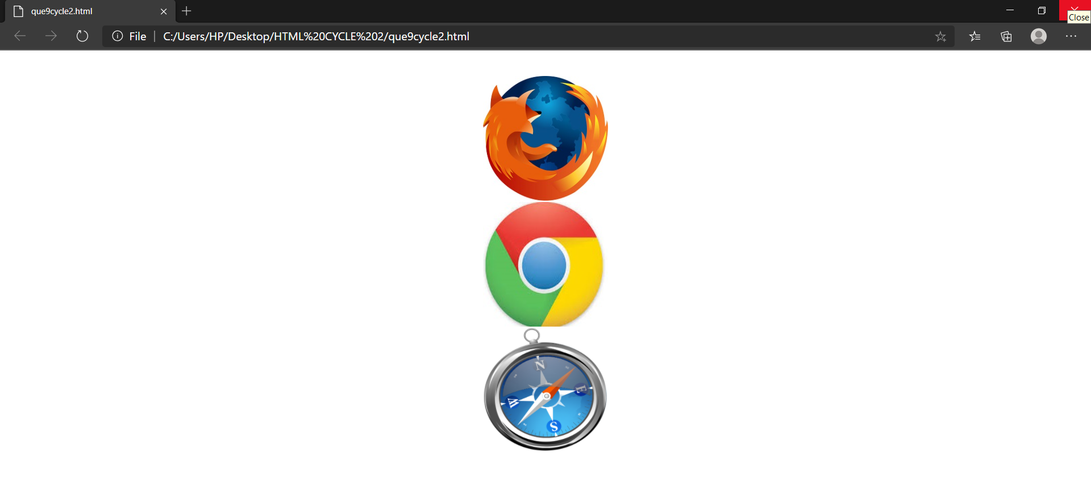

1. **Create the following html page using frames**

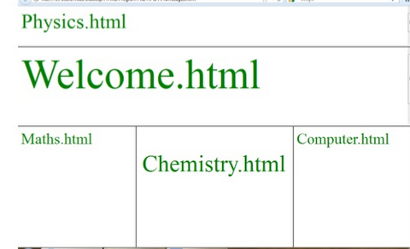

<html>

<head>

</head>

<frameset rows="20%,30%,*" border="6">

<frame src="Physics.html" name="Physics.html" />

<frame src="Welcome.html" name="Welcome.html"/>

<frameset cols="25%,50%,*" frameborder="6">

<frame src="Maths.html" name="Maths.html"/>

<frame src="Chemistry.html" name="middle down"/>

<frame src="Computer.html"name="Computer.html"/>

</frameset>

</frameset>

</html>

**OUTPUT**

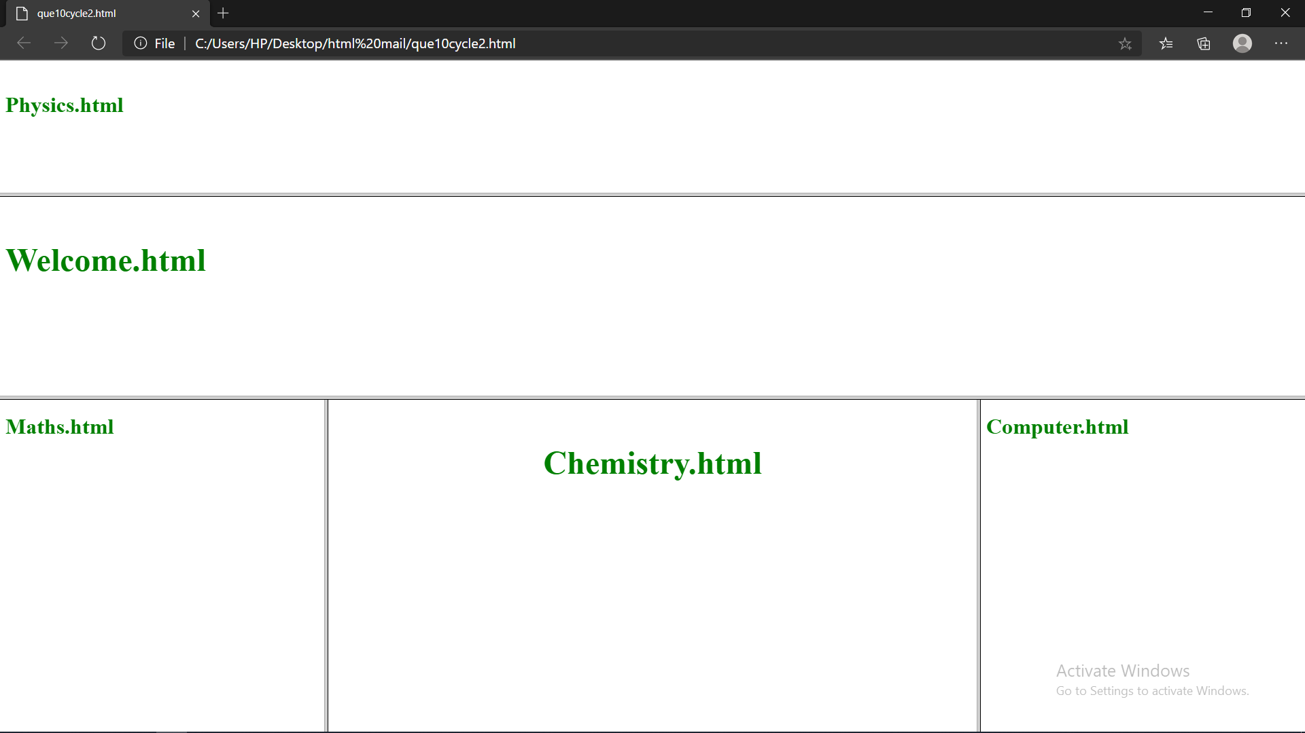

1. **Create an HTML page using frames which is similar to the following one.**

**In the left frame provide hyperlinks to 3 important monuments in world. On clicking that hyperlink an image of the monument should be displayed in right frame with suitable description**

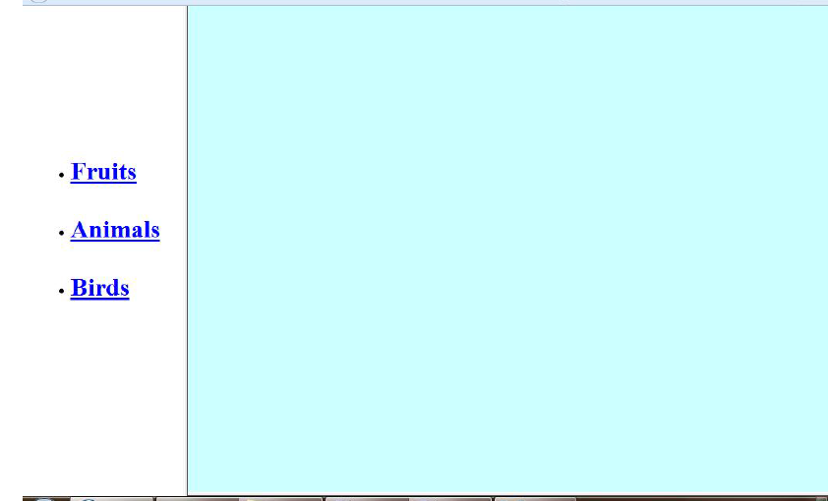

<html>

<head>

<title> index </title>

<style>

.div_1{ background-color:yellow; margin:20px; }

.div_2{ background-color:grey; margin:20px; }

</style>

</head>

<body>

<center>

<br>

<div class="div_1"><h1><font color="green" size="6" face="Cooper">FRUITS,ANIMALS,BIRDS</font></h1></div>

<div class="div_2"><font color="white" size="6" face="Cooper">

<ul>

<li>FRUITS</li>

<li>ANIMALS</li>

<li>BIRDS</li>

</ul>

</div>

</center>

</body>

</html>

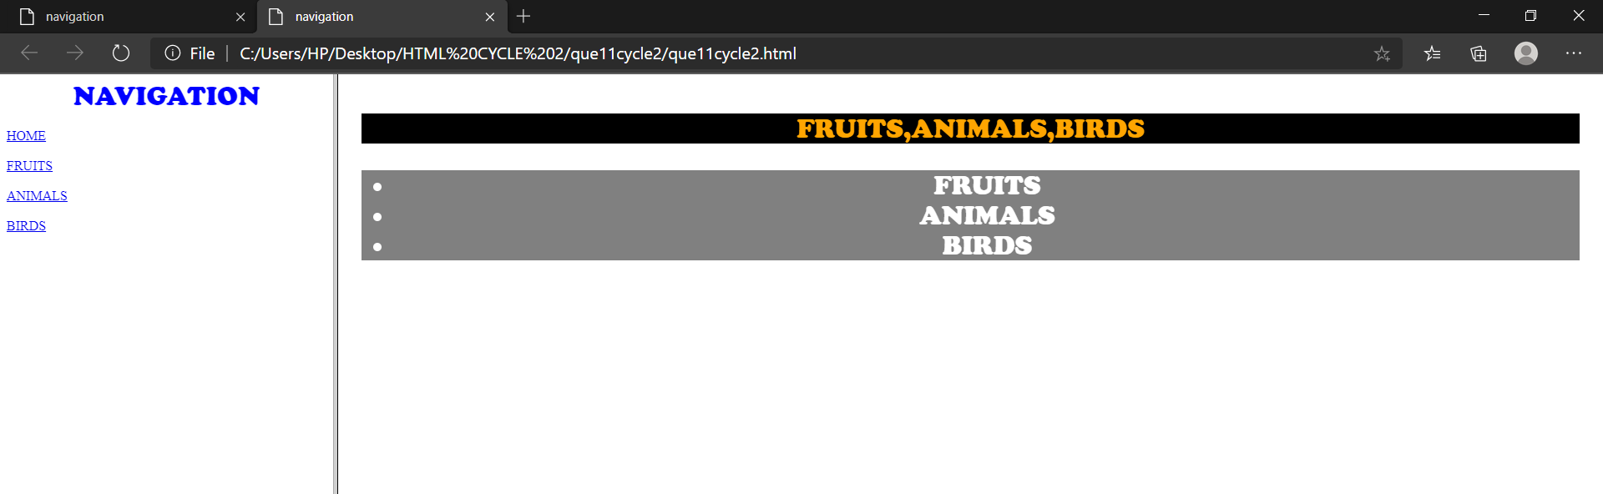

**Submitted by:**

**Anunadh Rajesh**